

Faculty of Technology and Engineering
Chandubhai S. Patel Institute of Technology (CSPIT) Department of Computer Science & Engineering
Date: 26/10/2026
Laboratory Manual

Academic Year | : | 2026-27 | Semester | : | 3rd
Course code | : | ITUE203 | Course name | : | WEB DEVELOPMENT FRAMEWORKS

Practical No: 1
Problem Statement:
Design the sitemap and wireframes for an EduPortal / Student Portal website. The planned portal includes a dashboard, attendance, timetable, materials, notices, student profile, settings, contact, and login pages.
Objective:
To plan the website's information architecture and page layouts before implementation, identify the main pages and navigation links, and represent the proposed interface using a sitemap and wireframes.

GitHub Repository Link:
Pending — add the wdf-practicals repository link after Practical 1 is pushed to GitHub.
Screenshots and Design Artifacts:
Figure 1: Wireframes for the proposed portal pages (dashboard, attendance, timetable, materials, notices, profile, settings, contact, and login).
Figure 2: Sitemap showing the main portal sections and the information planned for each section.
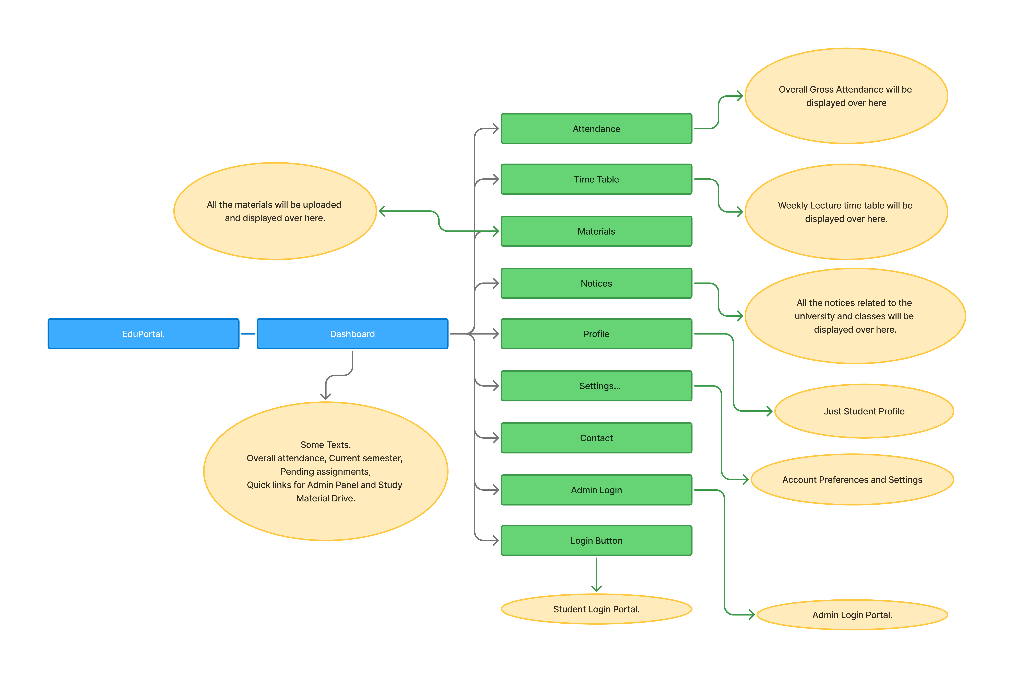
Figure 3: Student Portal project structure in Visual Studio Code, showing the HTML pages and CSS folder.
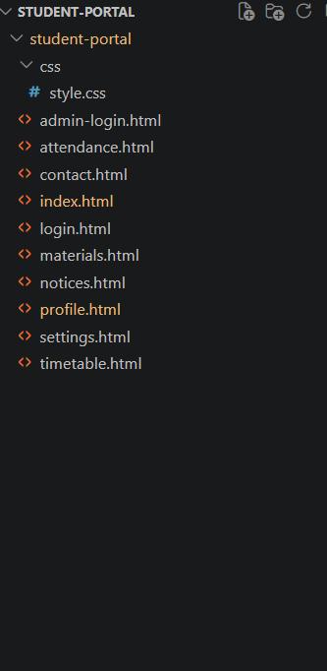
Result and Conclusion:
The sitemap and wireframes for the EduPortal / Student Portal were prepared. The design identifies the portal's main pages and gives a preliminary layout for each page. Practical 1 still needs to be committed and pushed to the wdf-practicals GitHub repository; the repository link should be added here after the push.

